Strategic Cost Analysis

Olin Business School ACCT 763

Washington University EMBA 60

Instructor: Mahendra Gupta, Simon 229
Phone 314-935-4565(O)
E-mail - guptam@wustl.edu
Assistants to Instructor: Ibra Sall; E-mail – i.sall@wustl.edu
Weikun Dong; E-mail – weikundong@wustl.edu

Course Overview and Objective
In recent years the field of cost management has undergone profound changes. Organizations are using new business models and management tools such as e-business, data analytics, activity-based management, value engineering, value chain analyses, customer profitability profiles, balanced scorecard, and economic value analysis to renew their strategies and to focus on how they serve their customers and stakeholders. The current thrusts of cost, quality, and customer service in managing business and operations have placed new demands on management and financial systems beyond the traditional costing for financial reporting. This course has been designed to reflect these changing needs of the markets, management, and information systems.
In this course, my objective is: (i) to provide a balanced blend between theory, applications, and current practices; and (ii) to highlight the importance of design, implementation, and use of effective strategic costing and control systems. We will study cost systems and their decision-facilitating aspects. We will examine the effects of strategy and incentives on cost system design and will provide a framework for evaluating alternative system designs and decision making. Finally, we will address common control issues through analysis of budgets, variances, and performance measures.
Olin’s Pillars of Excellence
Students will:
- Embody a values-based and data-driven ethos in their approach to all business situations
- Understand the global opportunities and challenges facing businesses
- Engage with business issues through the application of experiential knowledge, in addition to the rigorous technical skills acquired in the classroom
- Pursue world-changing initiatives with an entrepreneurial and innovative mindset and skillset

Course Material
- Textbook: The text for the course is Horngren’s Cost Accounting: A Managerial Emphasis, by Datar, and Rajan (hereafter denoted as HDR) 17th edition, Pearson. An e-text (electronic copy of the book) is available to you through MyLabAccounting. Information for accessing the e-text and ordering a loose-leaf paper copy of the book is included in the access card provided to you with the course material.
- Course Packet: The readings and cases for the course are available in your course pack and electronically on the LAD online portal. Please review the packet and familiarize yourself with the contents. If any part of the material is missing or not readable, please let me know and I will arrange for the replacement pages.
- Canvas Class Files Folder: Class files and other course related material would be made available on the Canvas class file. I will regularly post lecture notes, solutions to assignment problems, and any extra readings on this class file folder.

Online Resources
- E-Textbook: The access card included with your course material that has a redemption code to access an electronic version of your text. Use the code to sign-up as instructed (also included on the last page of this syllabus). Your Pearson course account will give you access to the text anywhere any time without carrying the heavy book around.
- MyLab Accounting: Your access code will also give you access to MyLab platform. It includes self-study material including practice problems with helpful hints leading up to solutions. It also includes other useful material such as application videos. Additional instructions are provided at the end of this syllabus.
- You also have access to very short video tutorials (by Prof. McLaughlin, formerly at Olin) for most of the concepts covered in this course. They can be found on the following link: https://www.edspira.com/index-managerial-accounting/

Class Organization
Class sessions are designed to highlight key concepts, clarify areas of difficulty, and provide a general framework to address the subject matter. Reading the assigned textbook material and cases in advance is strongly recommended for each class.
We will all learn more and better from regular class participation. Everyone is expected to prepare in advance the assigned problems and cases. I may randomly call on individuals to discuss a case or solution to an assigned problem. Be prepared to justify your answer with sound reasoning and computed solutions. As an encouragement, a part (10%) of your final course grade will depend on the quality of your participation in class.
Class notes for each class session will be provided in on the Canvas class file folder prior to the related class session. The class notes would primarily consist of copies of the power-point slides and highlight the concepts we will focus in class.
The course outline lists problems that are assigned for each class session. We will try to do most of these problems in the class session for which they are assigned. You may try to attempt the assigned in-class problems as a part of your preparation for the class. I will post solutions to these problems on the Canvas class file folder on the day of the class for which they are assigned. You do not need to turn in solutions to these assigned in-class problems.
To help you with your preparation and understanding of course topics, please try some “Practice Problems” on MyLab platform related to chapters assigned for each class session. We will not do any of these “practice problems” in class, rather they are available to you as additional material to check and enhance your learning of course topics. You can do these problems as per your need and at your own pace.
The best preparation for a class always entails working regularly, preparing solutions and answers to the assigned problems and cases for the class, and participating in class. In preparing for problems and cases, note down the points you find confusing and wish to discuss in class. If time is short, I may not be able to discuss all problems or address all points in class. However, I will try to address them after class or via email.

Assignments
Each study group must provide their answers to the assigned case questions at the beginning of the class session for which the case is assigned. There are five such case assignments. Each case assignment will also constitute 8% of your course grade.
Group assignments will be graded on a scale of 1.0 to 10.0. A score of 7.0 or more would denote a satisfactory performance; that is, your answers and write-up conveyed a general understanding of the subject topics. You must clearly show your calculations and work clearly to receive credit for the assignments. Please make sure that the group number and participating group member names are clearly identified on the cover sheet.
Each participating group member’s total grade for group assignments may be adjusted based on Peer Evaluation at the end of the course.
A list of the case assignment to be turned-in and due date are listed below:
- Mueller-Lehmkuhl January 17, 2025
- VMD Medical Imaging Center January 18, 2025
- SuperTasty Ice Cream February 14, 2025
- Hilton Manufacturing February 14, 2025
- Precision Worldwide February 15, 2025

Final Exam
There will be an individual take-home final exam for this course. The exam will be take-home, open book and open notes. I will post the exam on Canvas class folder on the last day of the course. The exam is intended to measure individual performance, so no collaboration will be allowed on the exam. The due date for Final is March 3, 2025.
Grading
Case Assignments (8% x 5 cases) 40%
Class Participation 10%
Final Exam 50%
Total 100%

Academic Honesty
The Olin Business School is a community of individuals with diverse backgrounds and interests who share certain fundamental goals. Primary among these goals is the creation and maintenance of an atmosphere conducive to learning and personal growth for everyone in the community. Becoming a member of the Olin community is a privilege that brings certain responsibilities and expectations. The success of Olin in attaining its goals and in maintaining its reputation of academic excellence depends on the willingness of its members, both collectively and individually, to meet their responsibilities. All individuals associated with Olin should conduct themselves with the utmost integrity in all aspects of their life, both on and off campus.
Homework and the exam for this class should be done according to the guidelines established within the Olin School Code of Conduct. You should not share any of the assignments, exam or course material with others without prior permission of the instructor.
I take the matters of academic integrity seriously and expect that you do, too. I encourage you to ask me if you have any questions about academic integrity in this course. Please refer to The Olin Honor Code for specific responsibilities, guidelines and procedures at the end of the syllabus. You may also consult with Cory Barron in the Executive Programs, if you have questions or concerns.

Feedback
I invite you to take a joint ownership of this course and provide me with your feedback and comments throughout the course. I encourage you to do so by taking a daily feedback survey or contacting me directly at an early date rather than waiting for a formal end of the course survey. I will try my best to respond to your concerns and accommodate most of your suggestions in a timely manner.
Disabilities
Reasonable accommodations will be made for students with verifiable disabilities. Students who qualify for accommodations must register through Washington University’s Center for Advanced Learning Disability Resources (DR). Their staff members will assist me in arranging appropriate accommodations.
Course Outline

Day 1 – January 16, 2025
Basic Concepts in Cost Management
Learning Objectives:
• Understand the role of cost information in a firm.
• Understand financial impact of choices we make in our organizations.
• Introduce basic cost terminology.
• Understand and determine the behavior of different types of costs.
• Apply the concept of learning curves to achieve cost efficiencies across the supply chain.
• Understand the role of cost in business planning and strategy decisions.
HDR: Chapters 1 (a quick background read), 2 and 10 (pages 366-371 and 382-387)
Problems: 2.46 and 10.23
Fundamentals of Job Costing and Product Line Profitability
Learning Objectives:
• Learn how to compute costs of products and services.
• Understand different methods of cost allocations.
HDR: Chapter 4 (pages 104-117)
Problem: 4.36
Day 2 – January 17, 2025
Fundamentals of Job Costing and Product Line Profitability
Learning Objectives:
• Understand the role of cost information in strategy formulation and competitive decision making.
Case: Mueller-Lehmkuhl
The company is facing competition from a new entrant supplying similar products at substantially lower prices. The financial reports are not very encouraging. M-L must find creative strategies to fight the new competition. But first it must clearly understand its costs and financials and the impact they have on its operating and marketing policies.
Prepare the following questions:
1. How much profit does Mueller-Lehmkuhl make on the sale of fasteners? On the sale and rental of attaching machines? (Hint: Prepare separate P&L for both fasteners and attachment machines.) (Hint: Pay attention to Exhibit 8 and its footnote)
2. How should Mueller-Lehmkuhl respond to the threat of the Japanese competition?
Activity Based Costing
Learning Objectives:
• How to determine if your costing system is working for you.
• Learn the basics of an activity-based costing (ABC) system.
• Understand what drives costs.
HDR: Chapter 5
Problems: 2.30 and 5.19
Cost-Volume-Profit Analysis
Learning Objectives:
• Learn how to compute breakeven points.
• Understand various assumptions underlying CVP analysis.
• Understand the role of the CVP analysis in planning, control, and management decisions.
HDR: Chapter 3 (skip the appendix)
Problem: 3.43

Day 3 – January 18, 2025
Cost-Volume-Profit Analysis
Learning Objectives:
• Understand various assumptions underlying CVP analysis.
• Learn about Operating Leverage and their impact on firm performance.
Problem: 3.33
Activity Based Costing and Value Analysis
Learning Objectives:
• Understand the role and importance of ABC for value analysis and total cost management.
Activity Based Costing and Business/Service Profitability Analysis
Learning Objectives:
• Understand the nature of and reasons for cross-subsidization in costing products and services.
• Learn Fundamentals of Time-based Activity Based Costing.
Reading: How to Solve the Cost Crisis in Health Care
Case: VMD Medical Imaging Center
VMD Medical Imaging Center is facing some important challenges. Despite efficiency improvements and cost-cutting initiatives carried out over the past few years, their profitability is shrinking, their prices are becoming uncompetitive and their main customer, a large regional research and teaching hospital, is threatening to seek alternative, more cost-effective, suppliers.
Prepare the following questions:
- Calculate the cost for each of the four tests in accordance with the existing system; the costing system proposed by Crest, and the costing system proposed by Posh.
- Which costing system would you choose? Why?
Customer Profitability Analysis
Learning Objectives:
• Apply ABC to manage cost and profitability across supply chains.
• Decisions and strategies to deal with unprofitable customers.
HDR: Chapter 15 (pages 596-605)

Day 4 – February 13, 2025
Budgets, Responsibilities, and Variances
Learning Objectives:
• Learn the role of budgets in organizations.
• Discuss the role of standards and variances for management control and continuous improvement.
• Understand the basics of variance analyses.
• Learn how to compute volume, sales, price, and efficiency variances.
• Learn to compute and analyze variance in overhead costs.
HDR: Chapters 6 (skip appendix) and 7 (skip journal entries on pages 257-258)
HDR: Chapter 8 (pages 282-293, skip journal entries on page 290)
Problems: 7.23 and 7.30; 8.23 and 8.24
Decision Making and Cost Analysis
Learning Objectives:
• Learn cost concepts for decisions: relevant costs, opportunity costs, joint costs, and past or sunk costs.
• Applications of the relevancy concept to outsourcing, make-buy, product-mix, special order, and other decisions.
• How to apply the principles of relevancy to short run and long run pricing decisions.
HDR: Chapter 12 (skip the appendix)
Problems: 12.32, 12.34 and 12.41

Day 5 – February 14, 2025
Management Control Process
Learning Objectives:
• Recognize basic conflicts between objectives of organizations and incentives of managers/workers of the organization.
• Illustrate the concepts of responsibility and controllability.
HDR: Chapter 15 (pages 615-622 on sales and market variances)
Case: SuperTasty Ice Cream Company
The case describes the financial planning and control system used by an ice cream manufacturing company. The case illustrates how many business problems may not be understood and remains uncorrected when managers focus only on bottom line variances. (Hint: Note that the case has already provided static (Exhibit 2) and flexible budgets and actuals (Exhibits 3-5) for 2016.)
(Prepare the questions included in the case.)
Putting It All Together – Cost and Variance Analysis and Decision Making
Learning Objectives:
• Understand the decision process and incentives of decision makers.
• Learn the role of cost information for strategic business analysis.
• Understand the incentive effects of using variances to evaluate performance.
Case: Hilton Manufacturing Company.
A family business company hires a professional manager to help its president, son of the former president, learn ropes of the business and make better decisions. One of major product is big money loser, while the best-selling product is coming under competitive price pressure. The company needs to formulate strategies for product mix, pricing policies, and may be survival.
(Prepare the questions included in the case.)

Day 6 – February 15, 2025
Cost and Pricing
Learning Objectives:
• Learn the role of cost information for strategic pricing and value analysis.
HDR: Chapter 14 (pages 562-578)

Performance Measurement Systems
Learning Objectives:
• Learn the importance of performance measurement in shaping organization’s strategy, decisions, and value.
• Learn trade-offs between various facets of measures of performance.
HDR: (Chapters 13 and 24 -- both these chapters are only for your reference. They can be read as needed after the class.)

Strategic Cost Analysis and Control
Learning Objectives:
• Applying many of the lessons learned in the course.
Case: Precision Worldwide, Inc.
A competitor has developed and introduced a superior product that is less costly to manufacture. Precision Worldwide must decide whether to match the competitor's product, when to do so, and how to price, given that it holds a large inventory of its now inferior product. (Hint: Pay attention to the footnote to Table A) (Prepare the questions included in the case.)

Take Home Exam -- Due: March 3, 2025

Olin’s Code of Conduct

The purpose of Olin’s Code of Conduct is to clarify expectations about academic and professional behavior. The Code is meant to encourage and clarify appropriate academic, classroom, interpersonal, and extra-curricular etiquette that is expected of each individual by their peers, the faculty and the institution. It is also intended to help describe the overall environment of excellence and professionalism that members of the Olin community seek to establish and to continually enhance. It is the responsibility of each member of the Olin community to uphold the spirit, as well as the principles, of the Code. Please refer to the publication Integrity Matters: Olin Business School Code of Conduct for specific responsibilities, guidelines and procedures regarding academic integrity.

Olin’s Code of Conduct as it relates to Academic Matters

The following is a summary of the Code as it applies to Academic matters:
Student Academic Violations. It is dishonest and a violation of student academic integrity if you:
- Plagiarize – You commit plagiarism by taking someone else’s ideas, words or other types of product and presenting them as your own. You can avoid plagiarism by using proper methods of documentation and acknowledgement.
- Cheat on an examination – You must not receive or provide any unauthorized assistance on an examination. During an examination you may use only material authorized by the faculty.
- Copy or collaborate on assignments without permission – It is dishonest to collaborate with others when completing graded assignments or tests, performing laboratory experiments, writing and/or documenting computer programs, writing papers or reports and completing problem sets (unless expressly discussed in class).
- Fabricate or falsify data or records – It is dishonest to fabricate or falsify data in laboratory experiments, research papers, reports or other circumstances; fabricate source material in a bibliography or “works cited” list; or provide false information on a resume or other document in connection with academic efforts. It is also dishonest to take data developed by someone else and present them as your own.
- Engage in other forms of deceit or dishonesty that violate the spirit of the Code.

If you have any questions regarding the definition of allowable behavior, it is your responsibility to ask for clarification prior to engaging in the collaboration.

Olin’s Code of Conduct as it relates to Professional Behavior

Expectations – Professional Standards of Conduct
Olin students are expected to conduct themselves at all times in a professional manner. Professional behavior includes, but is not limited to, the following:
- Attendance: Students are expected to attend each class session. Students who must miss a session for any reason should make every effort to notify the instructor prior to the class meeting.
- Punctuality: Students are expected to arrive and be seated prior to the start of each class session. They should display their name cards in all classes at all times.
- Behavior: Classroom interaction will be conducted in a spirited manner but always while displaying professional courtesy and personal respect.
- Preparation: Students are expected to complete the readings, case preparations and other assignments prior to each class session and be prepared to actively participate in class discussion.
- Distractions:
  - Exiting and Entering: Students are expected to remain in the classroom for the duration of the class session unless an urgent need arises or prior arrangements have been made with the professor.
  - Laptop, PDA, and Other Electronic Device Usage: Students are expected to not use laptops, PDAs, and other electronic devices in classrooms unless with the instructor’s consent and for activities directly related to the class session. Accessing non-course related online material during class is not permitted as they can be distracting for peers and faculty.
  - Cellular Phone and Pager Usage: Students are expected to keep their mobile phones and pagers turned off or have them set on silent/vibrate during class. Answering phones or pagers while class is in session is not permitted.
  - Other distractions: Those identified by individual instructors, such as side conversation during a lecture or class discussion.

PEARSON Mylab, Horngren’s Cost Accounting textbook : REGISTRATION AND Access TO PRACTICE PROBLEMS / E-TEXT / ILLUSTRATIon VIDEOS.

- Registration
You first need to register to the course by following the steps below as indicated in the last page of the course syllabus.
If you encounter any issues while attempting to open the registration page or the sign in page, please try an alternative web browser (Google Chrome, Safari, and Firefox seem to work properly). If the problem persists, please email Professor Gupta (m.gupta@wustl.edu) by attaching a screenshot of the error message you receive.

Instructions To register for Strategic Cost Analysis - EMBA 60:
- Go to https://mlm.pearson.com/enrollment/gupta31092.
- Sign in with your Pearson student account or create your account.
- Select any available access option, if asked.
  - Enter a prepaid access code that came with your textbook.
  - Select Get temporary access without payment for 14 days.
- Select Go to my course.
- Select Strategic Cost Analysis - EMBA 60 from My Courses.
If you contact Pearson Support, give them the course ID: gupta31092
To sign in later:
- Go to https://mlm.pearson.com.
- Sign in with the same Pearson account you used before.
- Select Strategic Cost Analysis - EMBA 60 from My Courses.

- Practice problems

- After signing in to your Pearson account via https://mlm.pearson.com, and selecting Strategic Cost Analysis EMBA 60 from My Courses, click on “Assignments” from the main menu shown on the left panel of the course page, then select “Do Homework”. (See screenshot below).

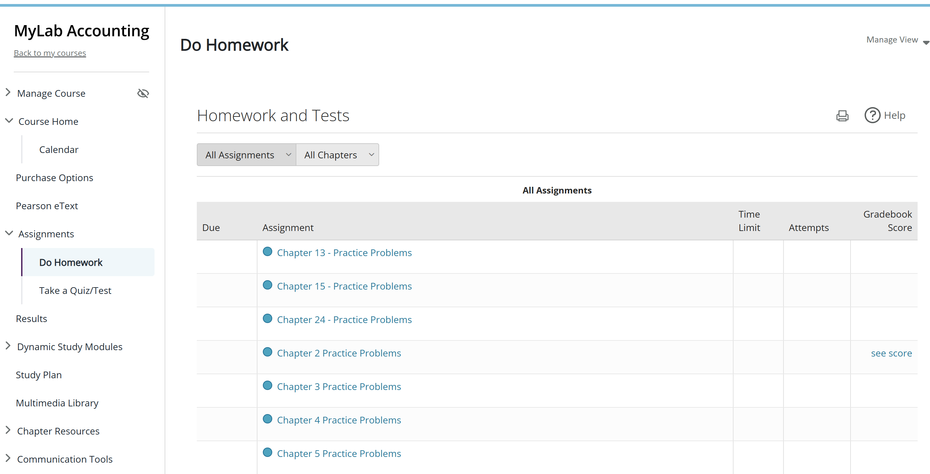

- Select the chapter for which you would like to work on practice problems from the list. Then, a list of related questions will appear.

- Click on the “Get Started” button or on one of the items listed to access the page that shows the contents of the questions.

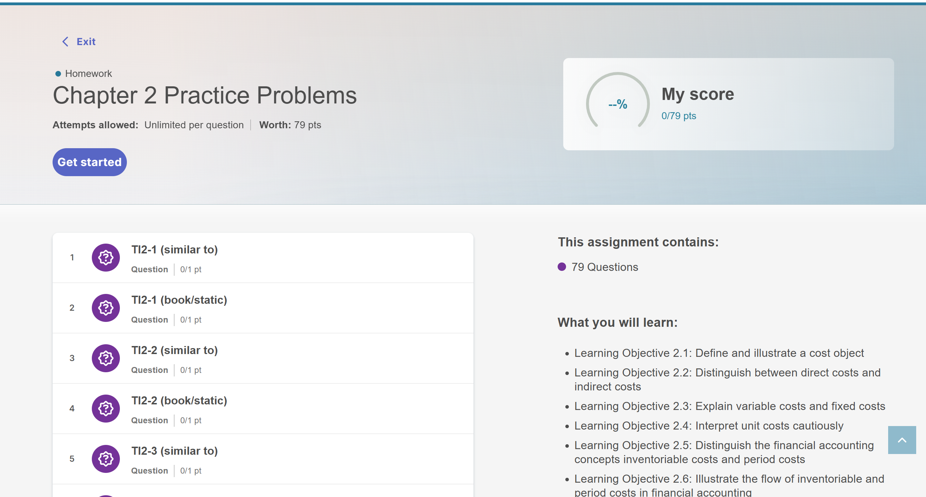

- You can scroll up or down the left panel to see the questions on the list and click on them to access their contents.
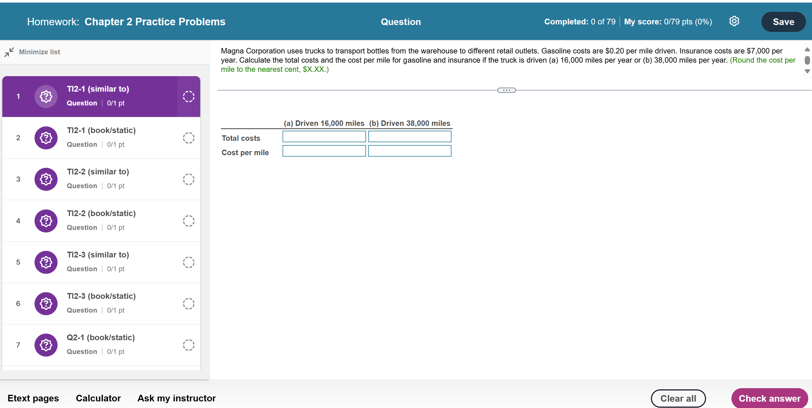
Instructions on the level of rounding.

- Once a question is selected, you can answer it, by either entering the computed number (if numerical problem) or selecting your answer from a list of choices (if multiple choices question), then submit. Please, keep in mind that certain questions may include specific instructions about the required level of rounding for your numerical answers. Failure to follow the specified rounding guidelines may result in an incorrect response. You have the option to verify your work by using the “Check Answer” button located in the bottom-right corner of the screen. Additionally, you're provided with multiple attempts to complete the task.

- eText (electronic version of the textbook)

- From the main menu on the left of the screen click on “Pearson eText”, then “Open Pearson+”. A new page will open, with the cover page of the textbook on the left.
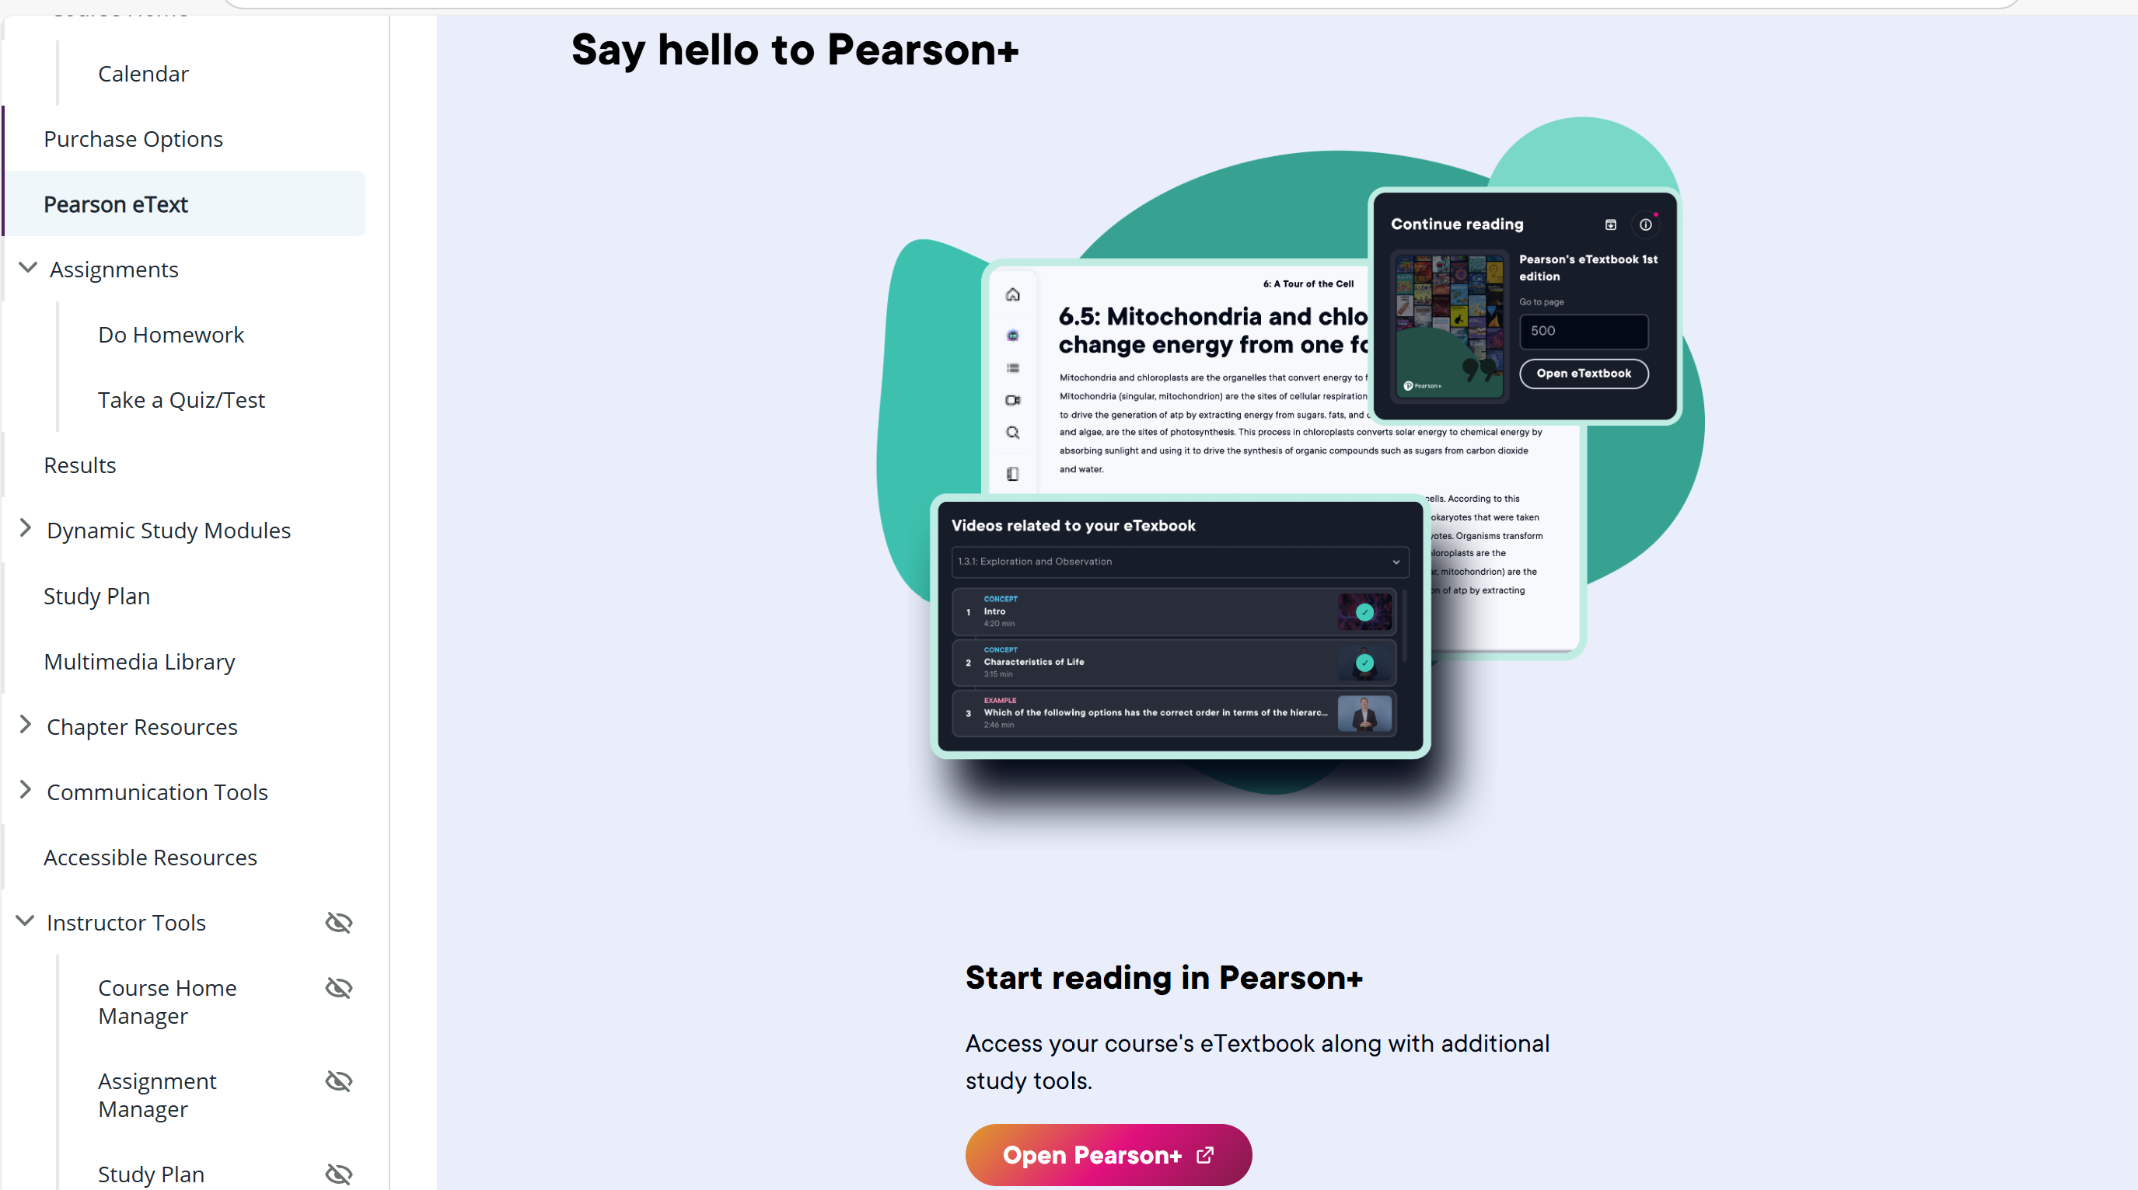

- Click on “Open eTextbook” to access the textbook. The cover page of the textbook will appear.

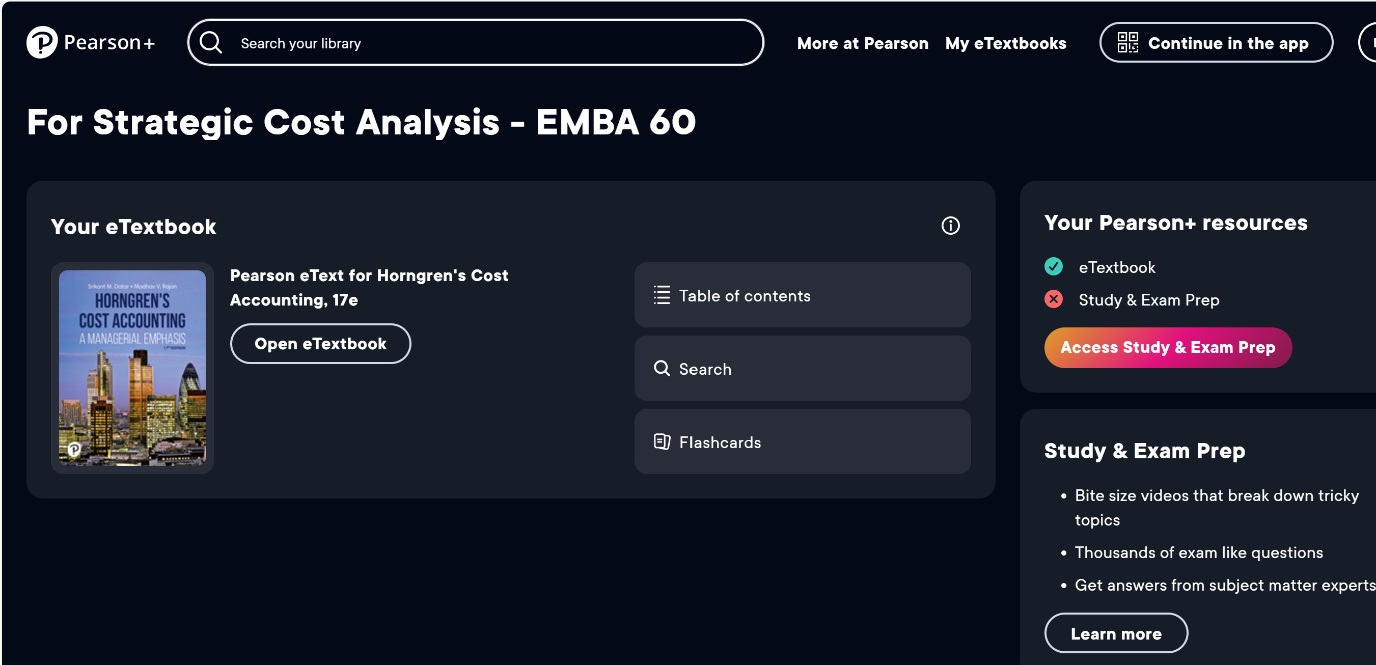

- To navigate, you can either use the arrows at the bottom of the screen or click on the table of contents icone on the left of the screen to see the list of chapter an sub-chapters for easier selection.
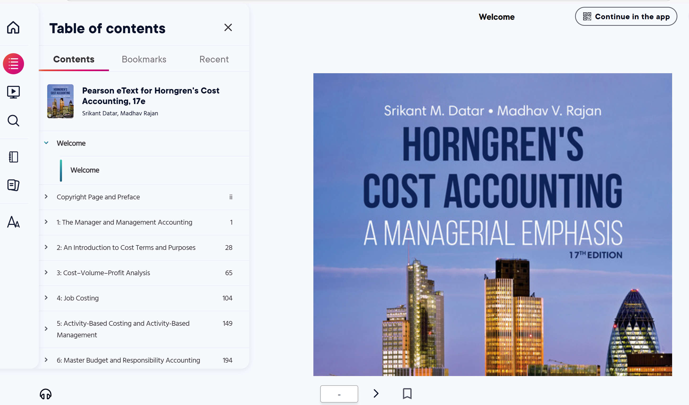

- Videos (short illustration videos that may help better understand the concepts covered in the course)

- Click on “Multimedia Library” from the main menu on the left of the screen, then select the book chapter from the list, and the media type (Video). After selection, click on “Find Now”.

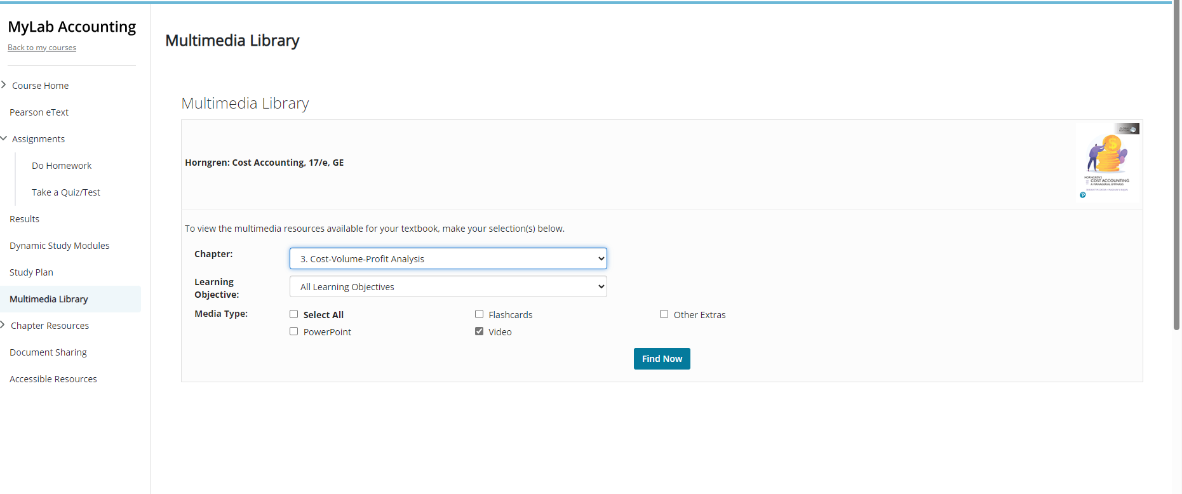

- Click on the corresponding video link.
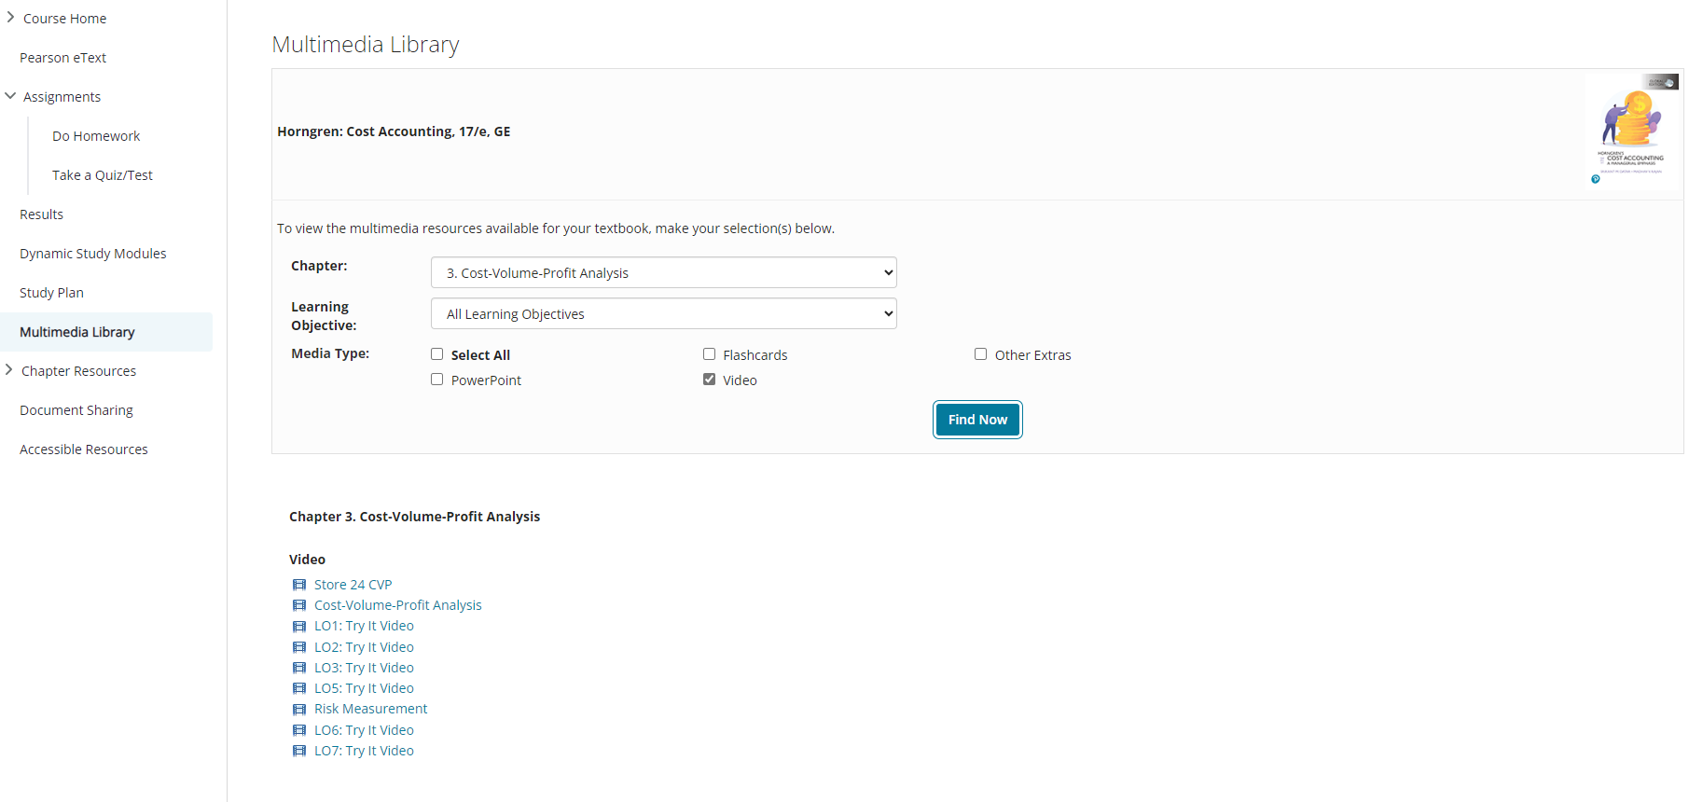

- Play and pause the video as you wish.
